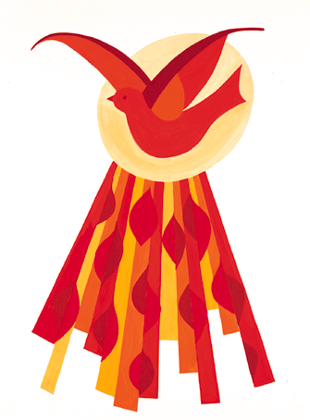
The Holy Spirit
pours out gifts
that enable us
to live out our Faith.
What gifts has the Holy Spirit
given to you?
And how do you use them?
What gifts has the Spirit given
to enrich the lives
of people in our community?

